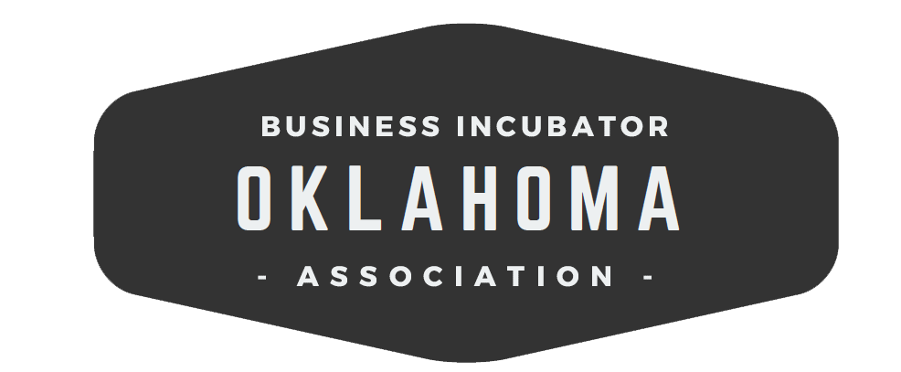

2019 Q4 Meeting Agenda | December 3rd, 2019
Training Room Annex,
Tulsa Technology Center Lemly Campus,
7906 East 33rd Street, Tulsa, Oklahoma

10:00 am | Welcome | Jim Eldridge, Ada Jobs Foundation
10:05 am | Introductions and Updates | Everyone
10:20 am | Tulsa Remote Program Presentation | Aaron Bolzle, Tulsa Remote, George Kaiser Family Foundation
11:00am | Break
11:15 am | Organization Business  - Minutes and Treasurer’s Report  - Presentation and Election of Officer Slate for 2020 | Rana Steeds  OKBIA Executive Committee
11:50 am | Lunch
12:15 pm | Presentation about Predict Point and Experience at the Forge | David Gillman, Predict Point
1:00 pm | Tulsa Tech Facility Tour
2:30 pm | Adjourn

OkBIA Members
36 Degrees North Co
Ada Jobs Foundation
Autry Technology Center
Caddo Kiowa Technology Center
Center for Emerging Technology and Entrepreneurial Studies at Cameron University
Central Oklahoma Business and Job Development Corporation
Duncan Area Economic Development Foundation
Francis Tuttle Technology Center
Gordon Cooper Technology Center
Great Plains Technology Center
Green Country Technology Center
Hemphill LLC
High Plains Technology Center
i2E, Inc.
Kitchen 66
Meridian Technology Center
Momentum3, LLC
Moore Norman Technology Center
Norman Economic Development Coalition
Northeast Technology Center
OCAST
Oklahoma Department of Commerce
Oklahoma Dept. of Career and Technology Education
Oklahoma City Chamber
OSU Riata Center for Entrepreneurship
Pioneer Technology Center
RCIDA
Project 3810, LLC
Sand Springs Chamber of Commerce
SCORE
Tonkawa Business Incubator, LLC
Tri County Technology Center
Tulsa Metro Chamber
UCO - The Catbird Seat

2019 Officers
President Jim Eldridge, Ada Jobs Foundation
Vice President Maureen Hammond, Norman Economic Development Coalition
VP Marketing Jennifer McGrail, Francis Tuttle
Treasurer Rana Steeds, Oklahoma Department of Commerce

