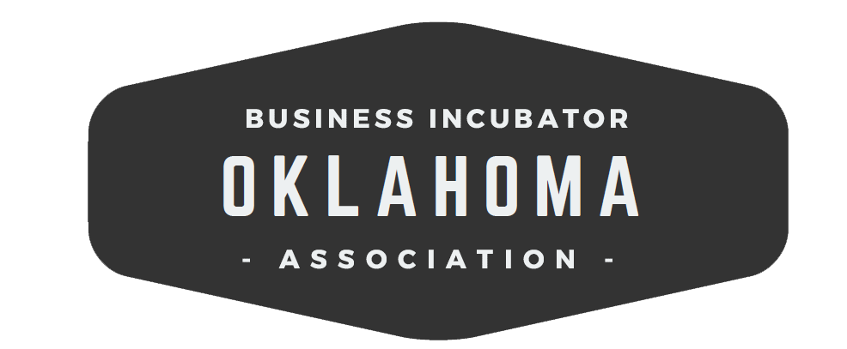

2020 Q1 Meeting Agenda | March 3, 2020
Catbird Seat
UCO, Santa Fe Plaza Location
101 N E.K. Gaylord Blvd. Ste. 1 | Oklahoma City, OK.

10:00 am | Welcome | Jennifer McGrail, Launch Pad FT
10:05 am | Introductions and Updates | Everyone
10:15 am | UCO, Institute for Learning Environment Design | Bucky Dodd, Ph.D. - Chief Learning Innovation Officer and Director, Institute for Learning Environment Design
10:30 am | Organization Business  - Minutes and Treasurer’s Report | Rana Steeds
10:45 am | Oklahoma Department of Commerce Innovation Initiatives | Melissa McLawhorn Houston - Founder, 929 Strategies  Oklahoma Innovation Director
11:45 am | Oklahoma Venture Forum
12:00 pm | Lunch
12:45 pm | Entrepreneurship and Government Incentives and OkBIA role in the legislative process | James Eldridge, Ada Jobs Foundation  Jennifer McGrail, Launch Pad FT
1:15 pm | Dallas Ecosystem Tour Discussion | OkBIA Executive Committee
1:30 pm | Catbird Seat Tour | Dawna Terrell - Director, Catbird Seat  Jesse West - Assistant Director, Catbird Seat
2:00 pm | Adjourn

OkBIA Members
36 Degrees North Co
Ada Jobs Foundation
Autry Technology Center
Caddo Kiowa Technology Center
Center for Emerging Technology and Entrepreneurial Studies at Cameron University
Central Oklahoma Business and Job Development Corporation
Duncan Area Economic Development Foundation
Francis Tuttle Technology Center
Gordon Cooper Technology Center
Great Plains Technology Center
Green Country Technology Center
Hemphill LLC
High Plains Technology Center
i2E, Inc.
Kitchen 66
Meridian Technology Center
Momentum3, LLC
Moore Norman Technology Center
Norman Economic Development Coalition
Northeast Technology Center
OCAST
Oklahoma Department of Commerce
Oklahoma Dept. of Career and Technology Education
Oklahoma City Chamber
OSU Riata Center for Entrepreneurship
Pioneer Technology Center
RCIDA
Project 3810, LLC
Sand Springs Chamber of Commerce
SCORE
Tonkawa Business Incubator, LLC
Tri County Technology Center
Tulsa Metro Chamber
UCO - The Catbird Seat
2020 Officers
President Jennifer McGrail, Launch Pad FT
Vice President Maureen Hammond, Norman Economic Development Coalition
VP Marketing Julie Griffin, Central Technology Center
Treasurer Rana Steeds, Oklahoma Department of Commerce

